Plot load current (I_{L}) variation of the circuit given in Figure-3
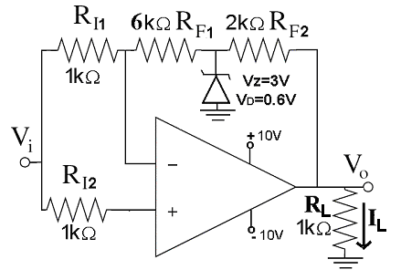
Figure-3
for –10V<V_{i}<10V (use constant voltage drop model for the reverse
and forward modes of the zener diode).

Solution:

The zener diode does not conduct for -0.6V<Vi<3V, and
Figure-S31 is valid;

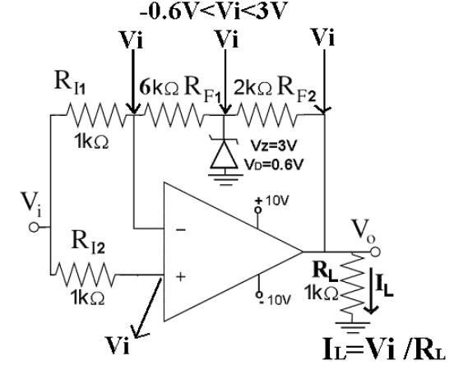
Figure-S31
As seen from Figure-S31, Vo=Vi for -0.6V<Vi<3V.

The zener diode operates in the zener region for 3V<Vi, and
Figure-S32 is valid;
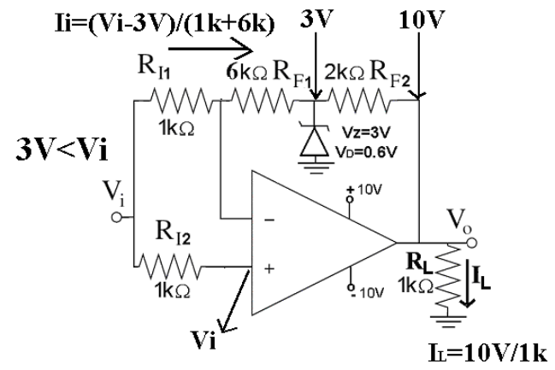
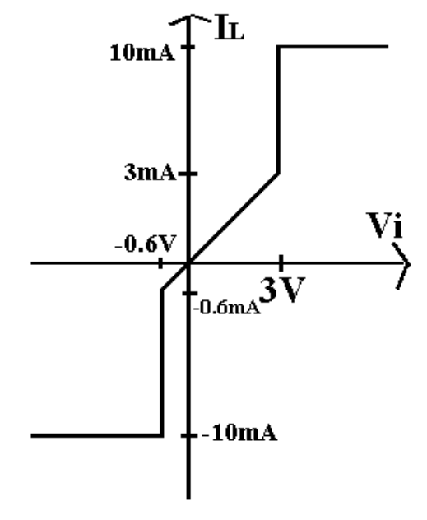
Figure-S34
Figure-S32

The zener diode operates in the forward bias for Vi<-0.6V, and
Figure-S33 is valid
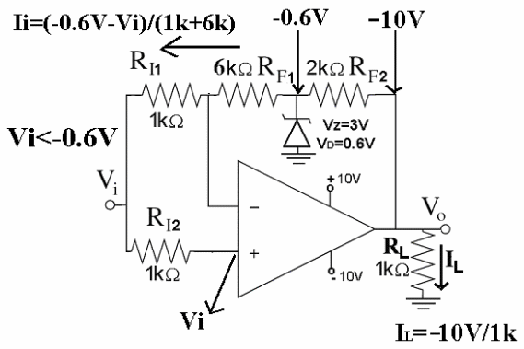
Figure-S33

The load current variation versus Vi is given in Figure-S34

